Secure level of RDS Systems

Juan Aramis Oposich

el17b502@technikum-wien.at

*Abstract*— *Radio Data System* is a broadcast feature to share information. That information is related to traffic, music information and radios as well as used by navigation systems. RDS is also used to warn drivers about traffic jams or accidents. This paper explains what impact an insecure communication system such as RDS, could have on the economy.

*Keywords*—Traffic control, Traffic Information System,

Communication standard, FM broadcast

I. WHAT IS RDS?

*Radio Data System* (RDS) is a fast communication standard for FM radio broadcasting. Blaupunkt, a German radio manufacturer, and the European institute for broadcast technology developed a common RDS standard in 1983 [1]. This single way communication standard is used to inform hosts about current traffic conditions and music information. Furthermore, navigation systems like Garmin and TomTom use RDS to calculate the quickest path to a destination. FM broadcasting provids five features at this point of time which are shown in figure 1. The features are mono audio, stereo audio, RDS, DirectBand and an audio subcarrier. RBDS is the American implementation located at 57 kHz [2].

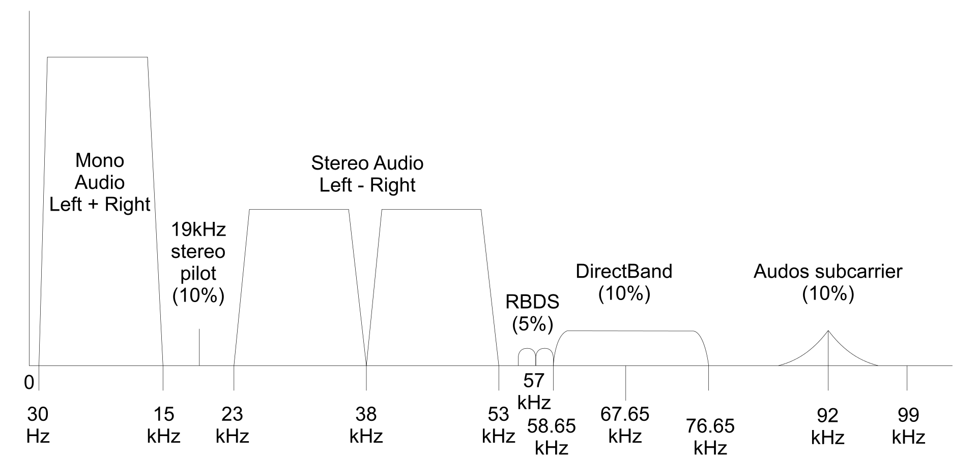

Figure 1. FM broadcast features [2]

Radio stations like O3, Kronehit and FM4 use various FM broadcasting features for example [3]. Also, the fire department, the police, the Austrian automobilemotorcycle and touring club (ÖAMTC) and other traffic service agency use the standard [2].

An RDS information block contains multiple traffic data [4]:

*Traffic Programme* (TP) code: Serving to identify programs that, from time to time, carry messages addressed to motorists.

*Traffic Announcement* (TA) signal: Switches a traffic announcement to a preset volume level and, if the motorist is listening to a cassette rather than the radio, stops the cassette and switches the radio on to receive the traffic message instead.

*Emergency Warning System* (EWS): A feature using a very small amount of data for emergency warning services such as national disasters and hazardous chemical spills.

1. PREVIOUS WORK

For two years I have been working with signal processing in telecommunication orientated embedded systems. During my studies, I started to modulate DVBT receivers and FM broadcasters which will also be discussed in my bachelor thesis. Both of these terrestrial broadcasting systems use bit interleaving and bit error forward correction to negate signal loss which will occur during transmission [5]. These methods were also used in RDS. My project manager works for the telecommunication department at the technical university-Vienna, Dipl.Ing. Dr. Bernhard Wess. He recommended a specific set up to modulate the FM broadcast system. In particular a simple receiver with analog to digital converter is the only needed hardware. This hardware is called SDRstick, Software Defined Radio. Figure 2 shows the used set up for RDS receivers.

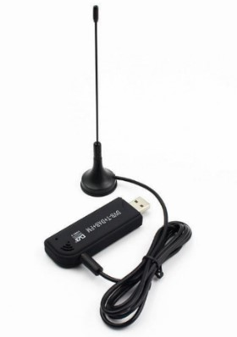

Figure 2. SDR-Stick

With this affordable setup, various signal processing can be achieved. RDS and FM stereo radio are some of the main features of FM broadcasting. This high frequency (HF) receiver could also be used as digital video broadcast receiver. The University of Strathclyde, Glasgow-Scotland, is known as one of the biggest software developers in this field – which?. The institute – which? engineered a new algorithm to transmit RDS [6]. Many methods such as the costas loop and the sequence of timming recovery have been used in my work.

1. AIM OF THIS PAPER

In this paper I elaborate the application of this broadcast system to..?. How it’s utilized now and how it can be utilized in our growing society. Furthermore, I want to point out the impact these applications have in the current economy – see before: which? What can be learned from discussing the implications? What's the point here? Make it clear, already here before you do it. The transmission standard Blaupunkt developed in the early eighties has since been adapted into modern technologies. Additional experiments should reflect the versatility of the standard.

1. BACKGROUND OF RDS

In the early eighties, blaupunkt tried to develop a fast and cheap communication standard for radios. Blaupunkt focused on music information – you can't connect sentences by commas - , any radio should be able to receive RDS signals [9]. The audio engineer’s reference book (authors! 1984) released the first RDS specification, including the following [10]:

*List of Alternative Frequencies* (AF): Stereo Audio needs this feature to obtain the nearest transmitter mast

*Clock Time and date* (CT): Time and date synchronization feature.

*Music Speech switch* (MS): An indicator of whether music or speech is broadcasted

*Programme Identification* (PI): A 16-bit code giving a unique serial number to a program service

*Programme Item Number* (PIN): Scheduled start time and date for an individual program

*RadioText* (RT): Text for display

*Programme Type* (PTY): Identifies the type of the program from a list of 31 possibilities – transition here from this information to what comes next; why was this important?

A conventional terrestrial receiver circuit can be utilized to receive the above stated features. DVB-T transmission employs the same terrestrial circuit with the significant difference that there is encryption. Figure 3 shows the demodulator for an RDS signal. This module is still applied on modern devices to this day.

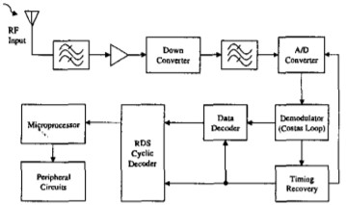

Figure 3. digital circut for RDS receivers

The traffic related features like TA and TP have been added – to what? in 1990 [11]. Traffic Message Channel (TMC) was later implemented into the standard in 2007. This channel made it possible to transmit traffic-related information by broadcasting them digitally. By incorporating TMC, the navigation systems were able to operate in real time [12]. Albeit, the terrestrial transmission method has remained the same since 1983. – and, why is this relevant? explain!

1. FINDINGS

The RDS standard did not include encryption for data transmission. – when? Online tutorials and books describe how the standard works and what equipment is utilized to build a RDS broadcast system on your own. Figure 4 shows the transmission standard [7]. – I do not understand what happens from here on out The implementation of a check + offset – what's that? serves a bit recovery purpose only. – meaning what? Bit recovery and bit check systems are embedded into every HF transmission. – ah, this needs to come before

Lead into this Figure, describe and explain; again, readability is an issue

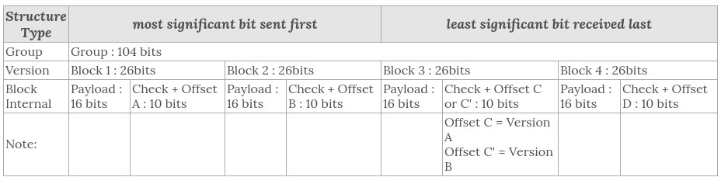

Figure 4. RDS transmission standard

Considering the fakt that RDS is basend on terrestrial broadcast and every HF antenna can reveive this signal, the transmission can be intercepted by any host. – and? is this an opporunity, a danger, if so why? Explain this. This standard is still used by the police, the fire department and the ambulance. Based on the encryption, this standard is not reliable, but it is by law. According to § 89 of the TKG, the malevolent manipulation or interception of their communication is illegal [8]. – so? You toss in facts; rather, name and explain and create an argument – this is what the course taught you. Remember the four steps and create your text according to them.

1. APPLICATIONS – of?

Information processing is key for any automated system. – this is so general that it carries no information; be precise and stick within the space you deal with here. These systems need input in order to operate properly. – again, too generl; this is true for a toddler, too For example, self-driving cars are very dependent on information about the road, traffic lights and pedestrian frequency. These conditions are measured by sensors and distributed to various receivers via RDS. For future applications, this standard can be expanded by additional information blocks. Moritz Dechant, senior developer Bosch, claimed in an interview that any external input for self driving cars would lighten the required computing power [13]. – so, how does that connect to the need for information processing you talked about before in this paragraph?

# TP and TMC inpact on traffic

Traffic jams are a big issue in european cities like Vienna. For those directly affected, the damage is quantified in loss of time. According to these estimates, every german citizen spends an average of 50 hours a year in traffic jams [3]. Lost working hours, traffic-related accidents and fuel consumption amount to a loss in over 100 billion euro.

To keep the timeloss short as possible, modern navigation systems operate in real time. Various algorithms help drivers find the best route possible using information provided through TMC and TP. This data contains traffic related information about nearby construction sites, congestion and roadblocks [14].

# Monitoring public transport data

The princip of data sharing helps to economize the infrastructure in Shanghai. The metropolis utilize the FM standard to record some data about rush hours. The puplic transport with buses are connectet with an TMC server, which can operate in realtime to broadcast some issues. One of the biggest advantages of RDS is that the standard doen’t need addinational infrastructure. The already mounted FM radio mast supports the broadcsating of traffic information. Figure 5 illustrate the TMC network [15].

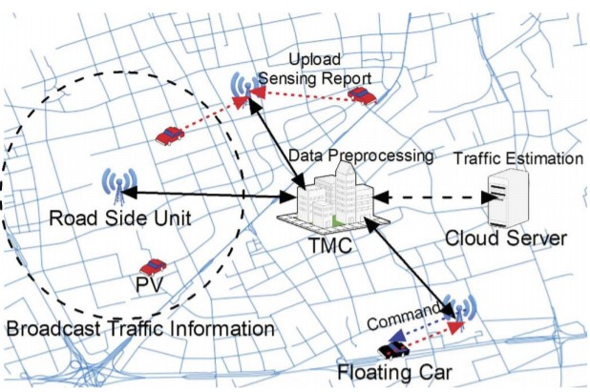

Figure 5. Urban information broadcasting

# Pollution

Bigger cities, like Stuttgart, also uses RDS to collect sensor datas like air polution. Sensor boxes are placed on highly frequented roads to alarm if a certan level of particulate matter. This warning system started in the year 2018 [16].

VII. EXPERIMENTS WITH RDS

# RDS of things - Smart City

In a turkish study (2019), a smart city prototype was built which served as the communication channel with the RDS standard. The prototype included traffic lights, emergency services and general traffic flow services. The prototype was also developed with 2G and LoRaWan. The replicated cities were London, New York and Moscow. The results are shown in Figure 6.The study shows that RDS is a lot cheaper. Furthermore, the introduction is also cheaper because the existing transmission masts can be reused [17].

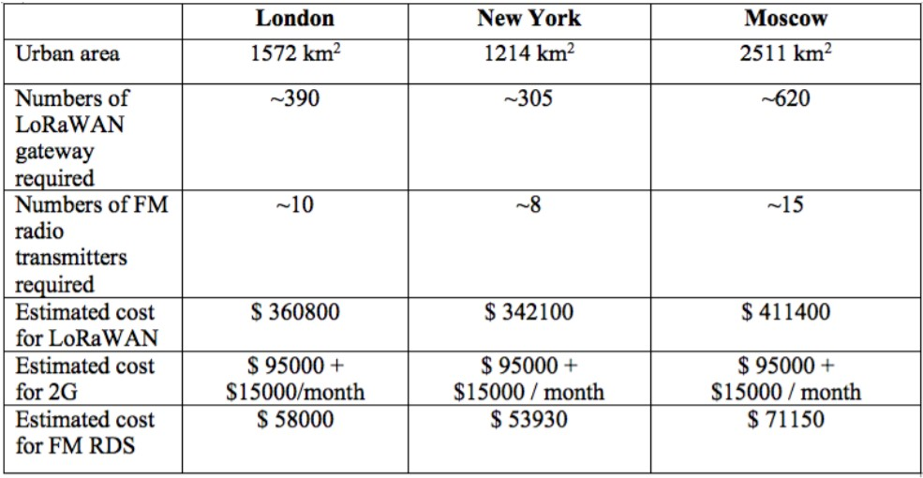

Figure 6. Comparesing RDS with 2G and LoRanWan

# Health monitoring using Radio Data Systems

In order to reduce the costs and ooccupancy rate of hospitals, a monitoring system has been presented by R.S. Deepak Ram in a studies. This system consists of one health controll unit and an central that receives the health data. The health controll unit indicates codition where a hospital treatment is needed and omit this information to the nearest central. RDS is implemented as communication standard in this experiment. According to the publisher of this experiment one problem is highlighted, the secure level of the system is based on FM broadcast [18].

VIII. IMPACT OF AN INSECURE STANDARD

A study shows that 95 percent of the drivers trust their navigation system [19]. Considering that the standard is not encrypted it gives space to manipulate the data broadcast. If a person has the intention to cause a traffic jam, by manipulation the RDS broadcasting, they will face no technical obstacles to fake information.

The TU traffic planer Hermann Knoflacher became infamous after he deliberately caused congestions to reduce the amount of commuters driving through Vienna. He strategically placed some construction sites on busy roads to form multiple traffic jam[20]. As a reaction to this, navigation systems tried to avoid those streets and thus commuters chose to drive around vienna rather than through it. This same result can be achieved by hackers utilizing RDS. By sharing wrong information on TMC and TP about certain streets, there could be an increase or decrease in the frequency that streets are used. As a consequence, streets could reach maximum capacity and start to congest.

IX. CONCLUSION

One of the greatest benefits of RDS is the simple implementation and the low-price setup. Existing FM radio transmission masts are reused for current applications. Even more features can be broadcasted within the RDS signal without changing the infrastructure. This is possible thanks to the broader FM frame of the RDS. This paper illustrated some versatile application where data sharing via RDS can optimize the infrastructure. Considering the fact that the standard has no encryption, it should not be integrated as a carrier of sensible data eg. medical and financial information.

The consequence of keeping the standard is to take the risk of being hacked, but it is a small price to pay, considering the low costs of the current systems. – There is so much more substantial discussion that is needed here; this result did not need research done on the matter

REFERENCES

[1] M. talbot smith. (1999) audio engineer‘s reference book.

[9] B. M. Dietmar Kopitz, *RDS: the radio data system*. Artech House, 2001.

1. *European FM Handbook*. The Directory of European FM

Broadcasting, 2003.

1. (2020). [Online]. Available: https://adac.de/verkehr/verkehrsinformationen/
2. B. M. Dietmar Kopitz, *RDS: the radio data system*. p. 31,

2001.

1. P. Dambacher, *Digitale Technik für den Fernsehrundfunk*. Springer, 2003.
2. R. W. Stewart, K. W. Barlee, and D. S. Atkinson, *Software defined radio using MATLAB & Simulink and the RTL-SDR*. Strathclyde Academic Media, 2015.
3. “Specification of the radio data system (rds) for vhf/fm sound broadcasting in the frequency range from 87,5 mhz to 108,0 mhz (iec 62106:2015),” 2016.
4. F. office of justice, *Telekommunikationsgesetz*, 2004.
5. J. Mayr, “Fm data coder for the radio data system,” SAE Technical Paper, Tech. Rep., 1986.
6. *Official NAB Privacy Policy*. National Association of Broadcasters, 2009.
7. B. C. Dan, “Radio data system-platform for traffic and travel information services,” *disasters*, vol. 3, no. 4, p. 5, 2017.
8. (2016). [Online]. Available: https://www.bosch.com/de/stories/automatisiertes-fahreninterview-mit-moritz-dechant/
9. R. Uyeki, K. Tamura, E. S. Ohki, and M. Kurciska, “Route calculation method for a vehicle navigation system,” Mar. 16 2010, uS Patent 7,680,596.
10. R. Du, C. Chen, B. Yang, N. Lu, X. Guan, and X. Shen, “Effective urban traffic monitoring by vehicular sensor networks,” *IEEE Transactions on Vehicular Technology*, vol. 64, no. 1, pp. 273–286, 2014.
11. (2018). [Online]. Available: https://www.stuttgart.de/feinstaubalarm/
12. A. Kutlay, “Rds of things: Using rds technology for smart cities,” in *2019 7th International Istanbul Smart Grids and Cities Congress and Fair (ICSG)*. IEEE, 2019, pp. 139–143.
13. R. D. Ram and G. Bhavani, “Health monitoring using radio data systems (rds),” in *2015 International Conference on Communications and Signal Processing (ICCSP)*. IEEE, 2015, pp. 1748–1752.
14. N. Stanton, S. Landry, G. Di Bucchianico, and A. Vallicelli, “Advances in human aspects of transportation: Part ii.” AHFE Conference, 2014, pp. 326–329.
15. (2018). [Online]. Available: https://https://www.diepresse.com/5382856/verkehrsplanerknoflacher-in-wien-staus-kunstlich-erzeugt/